

Linux on IBM Z Executive Advisory Customer Council

***Open Source on LinuxONE***

Friday, March 1st, 2019 8:30 AM – 1:00 PM

Hosted: Verisk 545 Washington Blvd in Jersey City

**(201) 499-2400**

You’re invited to join us for the next session of the Linux on IBM Z Systems Executive Advisory Council.

**RSVP Meetup URL** [**http://www.meetup.com/Linux-on-z/**](http://www.meetup.com/Linux-on-z/)

Linux is Linux is Linux – a common expression used to describe the operating systems similarities across platforms. LinuxONE and Linux on IBM Z have created a vibrant open source ecosystem for the platform and this council will discuss tools, and developments for the platform and how it fits in your enterprise.

For the first presentation – **Timm Bryant** from IBM will discuss how **IBM Event Streams** can be used as an enterprise integration tool to exchange data securely and reliably across applications. Timm will give an overview of how open source Kafka messaging works and what IBM Event streams brings as added value to the open source Kafka distribution.

After, **David Koppe** from MongoDB will discuss the relationship between IBM and MongoDB, as well as Mongo’s fit and experiences on the platform during this partnership.

In the next presentation **Neale Ferguson** will give a description and demonstration of using **OpenShift Origin** under Linux on Z. OpenShift Origin has been built around a core of Docker container packaging and Kubernetes container cluster management, augmented by application lifecycle management functionality and DevOps tooling. Neale will provide an overview of this open source application container platform specifically for Linux on Z.

IBM Program Director for Ecosystem Business Development**, Enyu Wang,** will present the strategy for the Open Source Ecosystem – she will discuss the roadmap for developments to the platform, the process by which open source components are added, giving context into development and futures for the platform.

**Agenda**

|  |  |
| --- | --- |
| 8:30 AM | **Arrival and Continental Breakfast** |
| 9:00 -9:15 | ***Opening Remarks and Introductions***  *Paul Houde - IBM, IBM Z Client Architect* |
| 9:15 -10:00 | ***IBM Event Streams – Apache Kafka***  *Timm Bryant – Cloud Integration Specialist* |
| 10:00 -10:45 | ***Mongo DB***  *David Koppe - Director of Information Strategy - NA East* |
| 10:45 –11:00 | *Break* |
| 11:00 -11:45 | **Managing and Orchestrating Docker Containers with OpenShift Origin** *Neale Ferguson – Principal Engineer Sine Nomine Associates* |
| 11:45 -12:30 | ***Open Source Ecosystem***  *Enyu Wang -* Program Director for Ecosystem Business Development |
| 12:30PM | ***Wrap up*** |
| 1:00 PM | ***Lunch at Dorians sponsored by IBM and Vicom Infinity (address below)*** |

**Directions to meeting location:**

**Verisk**

545 Washington Blvd Jersey City, NJ

(201) 469-3000

Lunch to follow: Dorian’s 555 Washington Blvd, Jersey City, NJ 07310

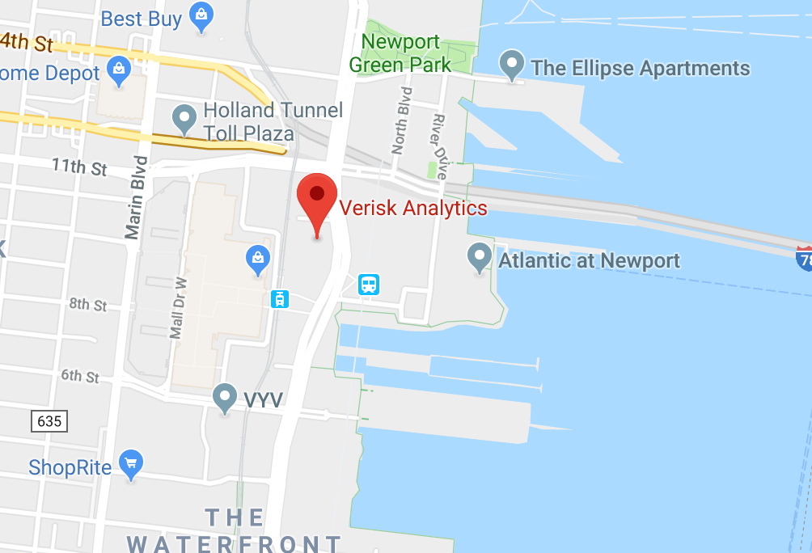

Previous council presentations can be found at:

<http://www-03.ibm.com/systems/z/os/linux/execcouncil.html>

As valued customers and trusted partners, your input to this council is very valuable. We continue to appreciate the candor with which you’ve shared your Linux on z Systems implementation experiences and requirements